AgentOS — Development Plan
Oct 4, 2026 · @Ankit
A backend-first, phased plan for AgentOS as an Electron desktop client over an always-on FastAPI service. UI screens are out of scope (built separately with AI); this covers the backend, the Electron shell and integration contract, and the system design — sequenced to de-risk the metering and settlement moat while shipping a working agent early.

Overview & approach
AgentOS is a control plane for an AI agent workforce. The product value — agents running 24/7, metering every unit of work, settling spend — only exists if the core runs always-on, server-side. So the architecture is backend-first: a FastAPI service owns the runtime, metering, and settlement; the Electron app is a desktop client onto it.
The key decision: one backend, two deployment modes. The same FastAPI codebase runs as (a) a local sidecar that Electron spawns — the dev and single-tenant/self-hosted mode — and (b) the cloud service that is the real multi-tenant product. The Electron client points at a configurable backend URL and never assumes which it is talking to. This keeps local dev fast, gives a self-hosted story for free later, and avoids forking the codebase.
What is in scope here: the FastAPI backend and all core services; the Electron shell (process model, backend connection and sidecar lifecycle, secure IPC, packaging, auto-update, the typed API client); the data model, system design, and phase plan.
What is out of scope: all UI screens and components — built separately with AI. The contract between them is a versioned REST + WebSocket API plus a generated client SDK, so the UI can be built against a stable surface in parallel.
Sequencing principle: ship a working agent end-to-end early (proves runtime + connectors + the client), instrument metering from day one, then build the defensible core (rating, budgets, settlement) on real usage data — rather than polishing breadth before the moat exists.

System architecture
The Electron client talks only to the FastAPI gateway; every core service lives behind it, server-side. The runtime, connectors, and the charging core (metering + wallet, highlighted) run in the backend whether or not the desktop app is open.
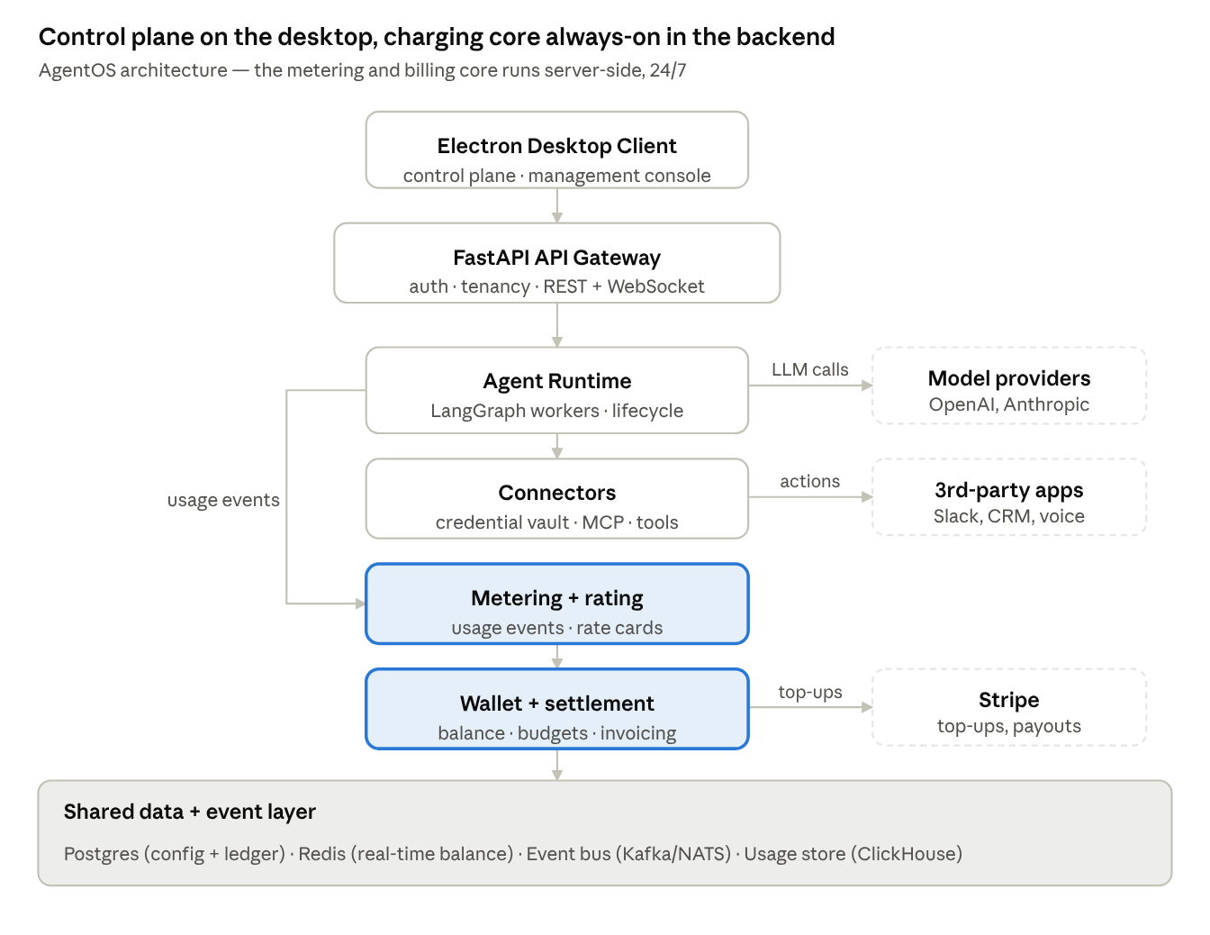
system architecture · control plane + backend core
The charging loop is the distinctive part: the runtime emits a usage event for every billable action, metering rates it against the rate card, and the wallet is debited — and the runtime checks the wallet's balance and budget before each action (real-time credit control, the telecom online-charging pattern). The gateway fronts all services; only the client is on the desktop.

Core design principles
These tenets apply in every phase; the phase plan is how they get built in.
- Control plane vs. data plane. The API/config path (managing agents, reading state) is separate from the execution path (agents doing work). They scale, fail, and deploy independently; a flood of agent runs never takes down the management console.
- Agents run as managed jobs, not request threads. Work is enqueued and executed by stateless workers, so an agent survives a client disconnect, a deploy, or a crash, and the fleet scales by adding workers.
- Event-driven metering, decoupled from execution. Every billable action emits a usage event onto a bus. Rating and ledger writes happen downstream, so metering never sits on the hot path of an agent doing its job.
- Exactly-once accounting. Every usage event carries an idempotency key; rating and ledger writes dedupe on it. A retried LLM call or a replayed event must never double-bill — the integrity of the whole product depends on this.
- Append-only ledger, balances are projections. Money movements are immutable ledger entries; a wallet balance is a derived view (with a cached running total for speed). This is auditable by construction and the right base for invoicing and reconciliation.
- Real-time credit control. Before a billable action, the runtime checks the wallet against budgets and balance and can throttle or stop — the telecom online-charging pattern, not after-the-fact reporting.
- Tenant isolation everywhere. Tenant id is on every row, every event, every log line, and is enforced at the data layer, not just in application code. Credentials are encrypted per tenant.
- Config is data, and versioned. An agent definition is a versioned record; a run pins the exact version it executed. Changes are diffable and rollback-able, and the audit log ties every action to a config version.
- Stable, versioned API contract. The client and the separately-built UI depend only on a versioned REST + WebSocket surface with a generated typed SDK — internals can change freely behind it.
- Observability is not optional. Structured logs, metrics, and distributed traces from Phase 0, with a trace id spanning client → API → worker → provider call, so cost and latency are attributable per agent run.

Tech stack
Boring, proven components by default; the only exotic choices are where the charging core or scale demands them. Recommendations noted where a decision is still open (see Risks & key decisions).
Layer | Choice | Why / tradeoff
Desktop shell | Electron + secure IPC | Cross-platform, web-based UI (fits building UI with AI). Heavier than native, acceptable for a management console.
API backend | FastAPI (async, Pydantic) | Typed, async, OpenAPI for free — generates the client/UI SDK. The team's core language.
Agent orchestration | LangGraph | Explicit stateful graphs, checkpointing, human-in-the-loop; matches existing LangChain/LangGraph depth.
Execution / workers | Temporal (recommended) | Durable, resumable long-running agent workflows with retries and timers. Heavier ops; Celery or Arq is a lighter v0 if needed.
Primary database | Postgres | Config, ledger, tenancy in one reliable store; row-level security for tenant isolation.
Cache + credit control | Redis | Real-time balance and budget checks, rate limits, distributed locks on the hot path.
Event bus | NATS → Kafka | Usage-event transport. NATS is simpler early; move to Kafka for durable, high-throughput, replayable metering at scale.
Usage store | ClickHouse | High-volume usage events and spend analytics; columnar aggregation. Timescale is a Postgres-native alternative.
Credential vault | Postgres + envelope encryption (KMS) | Per-tenant connector secrets, encrypted at rest. Graduate to Vault if secret sprawl grows.
Payments | Stripe (Billing + Connect) | Top-ups, invoicing, payouts — don't build a payment rail.
Connector protocol | MCP | Reuse the growing tool-integration ecosystem instead of bespoke adapters.
Auth & identity | OIDC provider (Clerk/Auth0) | Tenants, users, API keys now; SSO/SAML later for enterprise.
Observability | OpenTelemetry + Prometheus/Grafana | One trace id from client → API → worker → provider; cost and latency per run.
Packaging | electron-builder + FastAPI sidecar (PyInstaller) | Ships the client and the local backend together; auto-update for the client.

Core data model
The entities the core is built on. usage_event, rate_card, and ledger_entry are the heart of the moat — fix their shape before building breadth. Every row carries tenant_id.
Entity | What it holds | Key points
tenant | Organization account | Root of isolation and billing.
user | People in a tenant | Roles for RBAC (expanded in Phase 6).
agent | A logical agent ("employee") | Name, role, status; points at its current version.
agent_version | Versioned config | Model, tools, guardrails, knowledge refs, connector bindings. Immutable.
run | One execution of an agent | Pins agent_version; status, start/end, trace id.
action_log | Every step and tool call in a run | Append-only audit trail; refs to inputs/outputs.
usage_event | One billable unit of work | Provider, model, tokens/quantity, agent_id, run_id, idempotency key.
rate_card | Pricing | Per-model token prices, per-tool fees, platform fee; effective dates.
ledger_entry | An immutable money movement | Debit/credit, amount, currency; refs a usage_event, top-up, or invoice.
wallet | Tenant balance | Cached running balance + currency; budgets attached.
budget | A cap or limit | Scope (tenant or agent), period, hard/soft, action on breach.
connector | An integration instance | Type (Slack, CRM, MCP), granted scopes.
credential | Encrypted secret for a connector | Per tenant, encrypted at rest.
invoice | A billing statement | Period, line items rolled from the ledger, status.

Phase 0 — Foundations
Goal: a skeleton that proves the hardest unknowns and sets the rails everything else rides on.
Build:
- Monorepo: backend/ (FastAPI), desktop/ (Electron shell), shared/ (OpenAPI-generated client SDK, shared types). CI/CD, linting, test harness, containerized dev.
- Architecture Decision Records for the decisions in Risks & key decisions (worker engine, usage store, settlement-vs-BYO for v1).
- Electron ↔ backend contract: client talks to a configurable backend URL; Electron spawns and supervises the FastAPI sidecar in local mode; secure IPC (contextIsolation on, no node integration in renderer); auto-update wiring.
- Auth & multi-tenancy skeleton: tenants, users, API keys; tenant_id threaded through requests; Postgres row-level security switched on from the first migration.
- Observability baseline: structured logging, OpenTelemetry tracing, metrics — before features, not after.
- De-risk spikes: run one LLM agent loop; stream tokens to the client over WebSocket; capture token usage from a provider response and write one usage_event.
Exit criteria: a developer can launch the Electron app, which starts the local FastAPI sidecar, authenticates as a tenant, triggers a trivial agent loop, and sees streamed output — with a trace spanning client → API → worker.
Key risk: over-building the skeleton. Keep it thin; the spikes exist to retire risk, not to be production code.

Phase 1 — Agent runtime MVP
Goal: one real agent, end to end — configured, run server-side, fully logged, with metering captured (not yet billed).
Build:
- Agent config schema (agent + agent_version): role, model, system prompt, tools, guardrails, knowledge refs. Versioned and validated.
- Runtime kernel: agent lifecycle (create → start → pause → stop → kill); state and memory persistence; execution as a LangGraph graph with checkpointing.
- Job queue + stateless workers (the chosen execution engine): runs are enqueued, executed off the request path, and survive disconnects and deploys.
- Action logging: every step, tool call, and model call appended to action_log with the trace id.
- Metering hooks from day one: emit a usage_event per model and tool call with an idempotency key — written to a store, not yet rated.
- One template end to end (Support Desk is a good first): config → run → streamed output → complete audit log.
- Backend API surface for the client: agents CRUD, trigger run, stream run events over WebSocket, read logs.
Exit criteria: create a Support Desk agent from config, run it against a sample task, watch it stream, and inspect a complete action log and the usage events it generated — all server-side, resumable across a worker restart.
Key risk: agent reliability and guardrails. Invest early in step-level logging and safe tool execution; a runtime you can't observe can't be debugged or trusted.

Phase 2 — Connector framework
Goal: agents that safely touch real systems, with permissions and credentials as first-class, scoped objects.
Build:
- Capability abstraction: typed interfaces for messaging, data, and web (voice deferred to Phase 5). Agents declare the capabilities they need; the runtime grants only those.
- Connector SDK + registry: a uniform way to define, register, and discover connectors, with MCP as the primary protocol so the existing tool ecosystem is reusable.
- Credential vault: OAuth and API-key flows, secrets encrypted per tenant, short-lived tokens where possible.
- Permission scoping enforced by the runtime: an agent can only reach the connectors and scopes its agent_version grants — checked at call time, logged on every use.
- Two or three real connectors (e.g. Slack, a CRM/HTTP, email) plus a generic MCP/HTTP connector as the escape hatch.
Exit criteria: a Support Desk agent reads from and posts to Slack and a CRM using scoped, tenant-isolated credentials; an attempt to use an ungranted scope is denied and logged.
Key risk: the security surface. Credential handling and scope enforcement are where a breach would be worst — threat-model this phase specifically, and keep every connector call attributable in the audit log.

Phase 3 — Metering, rating & budgets
Goal: the control story — accurate per-agent cost and real-time budgets — on your own keys, before taking on payments. This is the start of the moat.
Build:
- Metering pipeline: usage events off the bus, normalized and enriched (provider, model, tokens, tool, agent, run, tenant), landed in the usage store.
- Rating engine: price each event against the active rate_card (per-model token prices, per-tool fees, platform fee), versioned with effective dates. This is the telecom rating pattern.
- Cost ledger: append-only ledger_entry per rated event, attributed to agent and tenant; wallet balance as a cached projection.
- Real-time budgets and caps: balance and budget checked before each billable action; soft caps alert, hard caps throttle or stop the agent (online credit control).
- Spend APIs for the client: cost per agent, per run, per period; the data behind the single unified view.
- Alerts and simple anomaly detection on spend spikes and runaway loops.
Exit criteria: run several agents and see accurate, per-agent rated spend within a small error of the providers' own numbers; set a hard cap and watch an agent stop at the limit.
Key risk: metering accuracy and double-counting. Lock in idempotency and exactly-once rating here — every later phase trusts these numbers.

Phase 4 — Settlement & payments
Goal: move into the payment path — one balance in, one invoice out, across every agent. This is where "single point to pay your agents" becomes real and where the margin is.
Build:
- Prepaid wallet: load a balance, reserve/hold against in-flight work, debit on rated usage, all through the append-only ledger.
- Stripe integration: top-ups, saved payment methods, and invoicing; webhooks reconciled into the ledger.
- Provider pass-through + markup: the rate card carries cost (what the provider charges) and price (what the tenant pays); margin is an accounted ledger quantity, not a guess.
- Invoicing engine: one statement per tenant across all agents, line items rolled from the ledger; usage-based and/or platform-fee billing.
- Reconciliation: compare metered/rated spend against providers' actual invoices; surface drift so margin never silently leaks.
Exit criteria: a tenant tops up once, runs a mixed fleet, and receives a single itemized invoice whose totals reconcile against provider bills within tolerance; a depleted balance stops further billable work.
Key risk: financial correctness and float. Being the payer means money-movement bugs are real losses — the append-only ledger, reconciliation, and tested edge cases (refunds, failed top-ups, disputes) are non-negotiable before onboarding paying tenants.

Phase 5 — Scale & reliability
Goal: hold accuracy and uptime as agents, tenants, and event volume grow by orders of magnitude.
Build:
- Horizontal worker scaling: partition the run queue per tenant, add backpressure and fair scheduling so one noisy tenant can't starve others.
- High-throughput metering ingestion: move the event bus to Kafka; stream-process usage events with exactly-once semantics — the same discipline as a high-QPS telemetry pipeline.
- Multi-provider routing and failover: a provider-agnostic rate card and model router with cost-aware selection and failover when a provider degrades.
- Caching and idempotency hardening across rating and ledger writes; replay tooling for the event stream.
- Voice/telephony capability subsystem (low-latency) for the Receptionist — heavier infra, added once demand justifies it.
- HA and DR: read replicas, usage-store sharding, backups, tested restore, defined RPO/RTO.
Exit criteria: a load test at target scale sustains correct, exactly-once metering and within-SLA run latency; killing a worker or failing a provider causes no lost or double-counted usage.
Key risk: correctness under load. Exactly-once metering is easy to break at scale; prove it with chaos and replay testing, not by hoping.

Phase 6 — Enterprise & hardening
Goal: clear the trust and expansion bars that a product handling money, credentials, and a whole agent fleet has to meet.
Build:
- Compliance path: SOC 2 controls, full audit logging, data-retention and residency policies, encryption and key rotation.
- RBAC + SSO/SAML: granular roles over agents, spend, and connectors; enterprise identity.
- Fraud and abuse controls: velocity limits, anomaly-driven holds, and prepaid-abuse protection — essential now that you sit in the payment path.
- Marketplace: share and install agent templates and connectors across tenants — an expansion and network-effect lever.
- Self-hosted / on-prem packaging: mature the local FastAPI mode into a supported single-tenant deployment for regulated buyers.
Exit criteria: an enterprise tenant onboards with SSO and scoped roles, passes a security review, and runs on isolated or self-hosted infrastructure with full audit export.
Key risk: scope creep away from the wedge. Enterprise features are necessary to move up-market, but sequence them against real demand so they don't starve the core product.

Phase roadmap & sequencing
The sequence ships a usable, connected agent by Phase 2 and the defensible core by Phase 4, with metering instrumented from Phase 1.
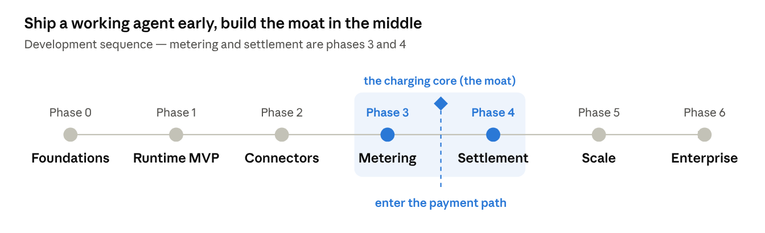
phase roadmap · 0 to 6
Phases 0–2 stand up a working, connected agent; Phase 3 adds metering and control on your own keys; Phase 4 crosses the gate into the payment path; Phases 5–6 scale and harden. Phases are ordered, not dated — attach calendar dates once team size is known.

Cross-cutting risks & key decisions
The open decisions to settle deliberately (as ADRs in Phase 0), framed as tradeoffs rather than blockers:
- Settlement vs. BYO-keys for first paying users. The plan ships metering + control on your own keys in Phase 3, then settlement in Phase 4. Shipping a bring-your-own-keys tier for revenue before full settlement de-risks the hardest part while still proving the control story. Decide how long you stay BYO before entering the payment path.
- Execution engine: Temporal vs. a lighter queue. Temporal buys durable, resumable agent workflows (worth it for long-running agents) at the cost of operational weight. Celery/Arq is faster to stand up. Pick in Phase 0; it is expensive to swap after Phase 1.
- Usage store: ClickHouse vs. Timescale. ClickHouse scales analytics further; Timescale keeps you in the Postgres world and simpler early. The metering volume you expect decides it.
- Build vs. orchestrate the agents. Building the native runtime (this plan) owns the whole stack and the margin. Alternatively, sit on top of existing agents as the governance + billing layer — faster to the wedge, less control. A hybrid is viable: orchestrate where it is faster, build native where margin justifies it.
- Desktop-first vs. web-first client. Electron fits a management console and the self-hosted story, but the product is inherently cloud; keep the UI a thin client over the versioned API so a web build is cheap later if the market pulls that way.
- Where agents execute in self-hosted mode. The local-sidecar mode is clean for dev and single-tenant, but 24/7 agents on a user's laptop is not viable — self-hosted means their server, not their desktop. Keep that boundary explicit.
The through-line: protect the metering/settlement core. Every decision that touches accounting accuracy, idempotency, or tenant isolation is load-bearing; most other choices are reversible.

